1. Write a blog on Difference between HTTP1.1 vs HTTP2

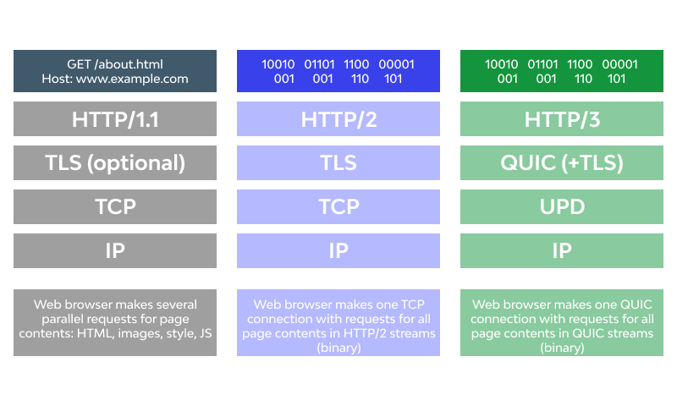

## **What is HTTP? Why is HTTP/2 faster than HTTP/1.1?**

[HTTP](https://www.cloudflare.com/learning/ddos/glossary/hypertext-transfer-protocol-http/) stands for hypertext transfer protocol, and it is the basis for almost all web applications. More specifically, HTTP is the method computers and servers use to request and send information. For instance, when someone navigates to google.com on their laptop, their web browser sends an HTTP request to the google servers for the content that appears on the page. Then, google servers send HTTP responses with the text, images, and formatting that the browser displays to the user.

#### **What is HTTP/1.1?**

The first usable version of HTTP was created in 1997. Because it went through several stages of development, this first version of HTTP was called HTTP/1.1. This version is still in use on the web.

#### **What is HTTP/2?**

In 2015, a new version of HTTP called HTTP/2 was created. HTTP/2 solves several problems that the creators of HTTP/1.1 did not anticipate. In particular, HTTP/2 is much faster and more efficient than HTTP/1.1. One of the ways in which HTTP/2 is faster is in how it prioritizes content during the loading process.

HTTP/1.1 loads resources one after the other, so if one resource cannot be loaded, it blocks all the other resources behind it. In contrast, HTTP/2 is able to use a single TCP connection to send multiple streams of data at once so that no one resource blocks any other resource.